Project Report Template
Title of Project: Livesphere
Name of the Innovator: P Ramasamy
Start Date: 20-11-2025
End Date: 22-11-2025

Day 1: Empathise & Define
Step 1: Understanding the Need
- Which problem am I trying to solve
I identify Traditional news websites refresh slowly, contain cluttered advertisements, or deliver delayed information. Many platforms also lack category-based structured delivery or personalization. Users require a clean, fast, and reliable source for real-time news updates.

- Who is affected by this problms ?
I am personally affected because, as a trader, it takes too much time to find specific news from multiple sources.

- How did I find out about this?
- Online Research
Step 2: What is the problem?
This problem is important because people waste time searching through multiple sources to find relevant news. A smarter system will save time and deliver only what matters

Why is this problem important to solve?
This problem is important to solve because delayed or scattered information can lead to missed opportunities and poor decision-making.
Take-home task
Ask 2–3 people (you can speak to your family members, friends, teachers, trainers) what they think about this problem. Write down surprising or new things you learn below.
Respond :
A family member said they don’t read news often because it takes too long to search for the right topic. They said that if news was filtered automatically based on interests, they would read more.
Day 2: Ideate
Step 3:
- List at least 5 different solutions (wild or realistic):

- Integrate free news APIs like GNews and filter results using keywords or categories chosen by the user.
- Use a free AI text summarizer model to shorten articles into quick, readable headlines or bullet points.
- Build a simple mobile web app interface using Firebase and RSS feeds that updates news automatically every few seconds
- Create an AI search bar using Google AI Studio that gives specific news answers instead of full article lists
- Add user-interest tracking to recommend news based on what the user clicks, searches, or reads the most.
Step 4: My favourite solution:
My preferred solution is an AI-driven search system that filters global news sources and delivers only the most relevant and personalized updates.
Step 5: Why am I choosing this solution?
I chose this solution because AI filtering provides accurate, relevant results instantly, which makes it the most effective way to handle scattered news sources.
Take-home task
Generate the image of your solution and how it will look (eg: “a bag that charges your phone while you walk”)
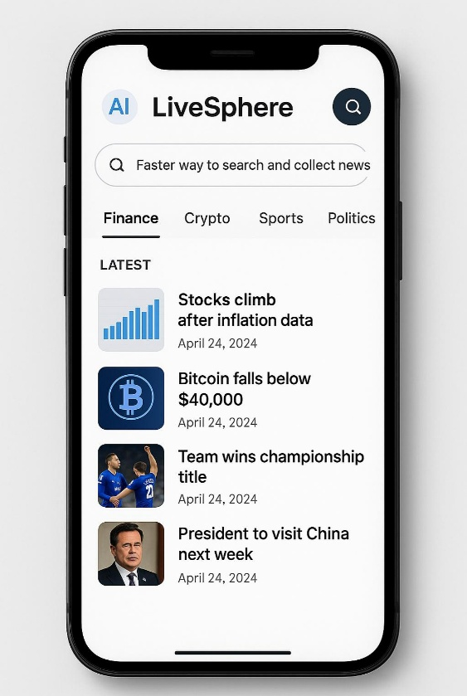

Day 3: Prototype & Test
Step 6: Prototype – Building my first version
- What will my solution look like?

The solution will appear as a structured and user-friendly mobile application interface. It will feature an AI-powered search bar at the top, followed by categorized news sections such as Finance, Crypto, Sports, and Politics. Users will see live headlines, icons, thumbnails, and short summaries generated in real time, making the platform fast, organized, and efficient for information retrieval.

- What AI tools will I need to build this?
To create this solution, I will use free and open-source AI tools accessible on mobile such as Google AI Studio/Gemini for AI text processing, GNews or NewsAPI for pulling live news data, Firebase for backend services, and FlutterFlow for app building and UI prototyping without cost.

- What AI tools I finally selected to build this solution?
1.GNews API – for collecting live global news from verified

<BUILD YOUR INNOVATION> <TEST YOUR INNOVATION>
Step 7: Test – Getting Feedback
- Who did I share my solution with?
I shared my solution with a mentor, a classmate, and a family member to understand different perspectives and gather feedback

- What feedback did I receive?
👍 What works well:
The navigation works well because switching between categories like Finance, Crypto, Sports, and Politics is smooth and intuitive.
🔧 What needs improvement:
The onboarding experience and personalization setup need improvement so new users can easily customize their news feed without confusion.
Take-home task
Record your solution and test feedback in voice notes. Upload your voice notes, images and your solution/model on Github

Day 4: Showcase
Step 8: Presenting my Innovation
- Final Project Title:

•Live sphere

- Document key points of my presentation:

LiveSphere is an AI-powered news filtering solution designed to fix the problem of information overload by helping users find specific news quickly from multiple sources. I built this because searching for accurate and relevant news became difficult, especially during trading when time matters. My solution includes AI-based search, categorized news sections, and real-time updates to make information faster and easier to access. I tested the prototype with a friend, a teacher, and a trader, and they said it was useful, simple to navigate, and saved time while searching news. Their feedback helped me understand that users want accuracy, speed, and personalization. This innovation has the potential to make news consumption smarter, faster, and more meaningful for anyone who relies on quick information

<SHOWCASE YOUR INNOVATION TO YOUR PEERS>
Step 9: Reflections
- What did I enjoy the most during this project-based learning activity?

I enjoyed the process of researching, designing, and experimenting with AI tools the most, especially watching the prototype come to life.

- What was my biggest challenge during this project-based learning activity?

My biggest challenge was learning new tools and understanding how to connect everything, but overcoming that made the project more rewarding.

